EN
Installation & User Manual

Bi-Polar Ionisation Air Virus Killer

Model: DI-AMSW-1000 / DI-AMSB-1001

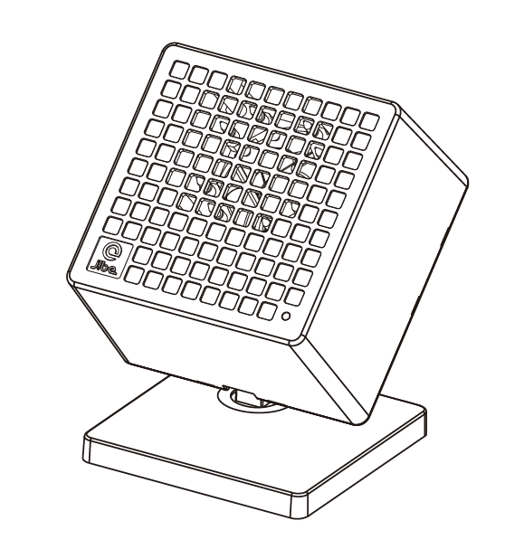

TABLE OF CONTENTS

- Introduction
- Package contents
- Safety instructions
- Installing and using the device
- Cleaning and maintenance
- Product specifications
- Storage & transportation
- Disclaimer

1) INTRODUCTION

The bipolar ionisation virus killer is an air disinfection device which utilises leading bipolar ionisation technology, replicating the earths own defence mechanism against air pollution, by extracting harmful particles and viruses from the air and dissolving them. It installs in less than a minute and is ready to output 180 million positive and negative ions per cm³, effectively killing airborne pathogens. The blue LED indicator shows that the product is operating, killing air viruses, and therefore creating a safer and cleaner environment.

2) PACKAGE CONTENTS

- Bipolar ionisation virus killer
- Power cord with UK plug
- Wall mount back plate and screws
- User manual
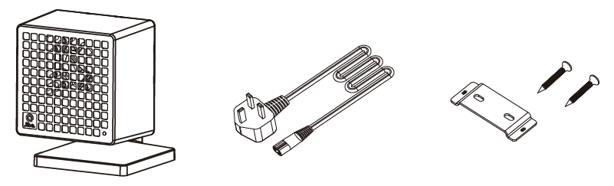

Air virus killer Power cord Back plate and screws

3) SAFETY INSTRUCTIONS

The following precautions must always be taken in consideration before using the “Bipolar ionisation virus killer”, hereinafter referred as the “device”.

General information
- Always read the instructions carefully before use.
- Only use this device in accordance with the instructions in this user manual.
- This device is not a toy and should not be handled by children.
- This device is intended for indoor use only
• WARNING! The packaging material is not a toy and should not be used by children. Risk of suffocation!

Electricity and Ventilation

- Before use, check that the mains voltage is the same as the mains voltage stated on the rating plate of the device.
- Make sure your hands are dry before touching the device, power cord or plug.
- Plug the power plug into an electrical outlet with earthing that is easily accessible at all times.

WARNING!
- Never cover the device to prevent overheating and potential fire hazards.
- Make sure that the device and does not come into contact with heat sources, including naked flames, hot hobs, etc.

WARNING!
- Regularly check the power cord for any signs of damage. In the event of any damage, you should cease using the device.
- In the event that the device has fallen on the ground and/or shows any signs of damage during use, switch OFF the device and remove the power plug.
- Make sure the power cord cannot be trodden on or pinched to prevent damage.
- Do not allow the power cord to hang over sharp edges and keep it away from hot objects and naked flames.
- Do not place cable in footfall areas to avoid people tripping.
- Remove the power plug from the power socket if the device has not been used for long periods of time.

WARNING!
- To reduce the risk of fire or electric shock, protect the device from dripping or splashing water and any other objects containing liquids, for example, vases. These objects should not be placed on or near the device.

Use
- Avoid locations subject to vibrations, cold or humidity.
- Do not expose the device to heat sources, direct sunlight, excessive humidity, and/or corrosive environments.
- Do not place the device under any mechanical stress.
- Improper use of the device could damage the product.
- Please handle the device with care. Impacts or falls, even from a low height, can result in damage to the device.
- Do not open the casing as this may result in electric shock.
- Do not attempt to disassemble or repair the device or modify it in any manner.
- The device must be serviced if it has been damaged in any way, i.e., the power supply cord/plug is damaged; liquid has been spilled; objects have fallen into it; it has been exposed to rain or moisture; it has been dropped or does not operate properly.
- Do not use abrasive cleaning solvents to clean the device.
- Do not use foreign objects to clean the device.

Important information, follow these instructions

- This device can be used by children aged 8 and over and people with restricted physical, sensory or mental capacity, an/or a lack of experience and expertise, provided they are under supervision or have been given instructions how to safely use the device and are aware of the potential hazards.
- Children must not play with the device. Cleaning and maintenance must not be done by children unless they are over the age of 8 and under supervision.
- Only use the device indoors, in dry areas and not in the vicinity of water, other liquids or humidity.
- Do not use the device if it, or the cable or power plug has fallen into water or any kind of fluid.
- Never immerse the device, cable and power plug in water or any kind of fluid.
- Do not pick up the device if it has fallen into water or any kind of fluid. Remove the plug from the power socket immediately. Do not use the device again.
- Install the device on a flat and stable surface, or wall, free from vibration.
- Do not switch ON the device until all of the accessories have been properly installed.
- Remove the power plug from the power socket if the device is unused for long periods of time.
- When removing the plug from the power socket, pull the plug itself, not the cable.

4) INSTALLING AND USING THE DEVICE

- Open the packaging carefully when removing the device.
- Make sure the device is complete and free from damage.
- If any components are missing or damaged, contact the vendor and do not use the product.
- Retain the packaging or recycle it in accordance with local regulations.

Parts & features device

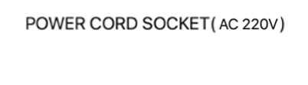
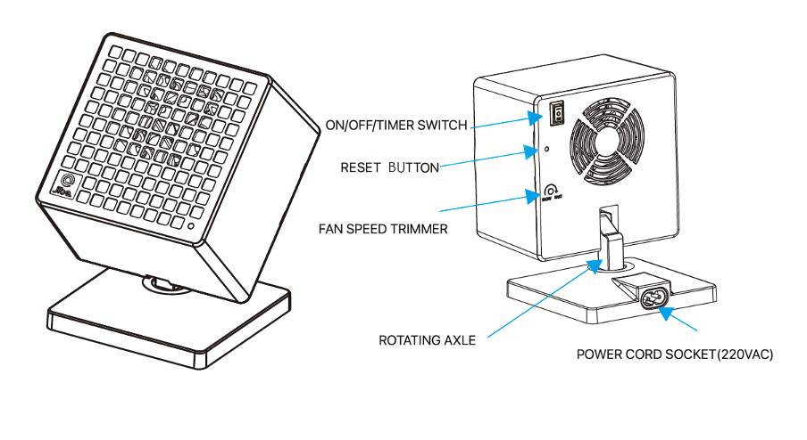

Installation

- Do not connect to power before mechanical installation is complete.
- Always disconnect power to the unit before handling the device.
- Mount or install the device in a location which allows for future access.
- Do not mount the device in location where the ionisation outlet will be blocked.

There are two modes of mounting: (1) Desk stand (2) Wall mount

- Desk stand

- Put the air virus killer on a flat, stable surface.
- Adjust the body of device to an appropriate angle.
- Rotate the body of device horizontally to a desire angle.

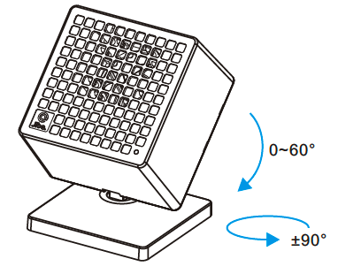

- Connect the power cord to the socket of stand at the back.
- Plug in power cord to AC main(AC 220V).

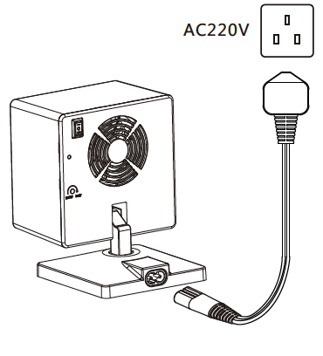

- Wall mount

Install the back plate on wall by the screws provided.

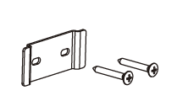

Slide in the stand of device and pull downwards.

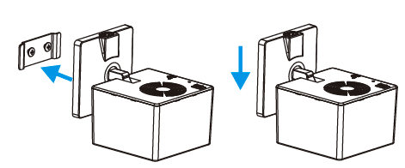

Adjust inclination angle to an appropriate angle.

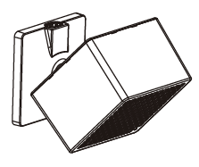

Connect the power cord to the socket of stand at the back.
Plug in power cord to AC main(AC 220V).

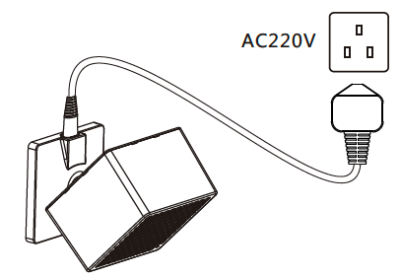

- After installation, turn on the device by switching the ON/OFF/TIMER switch to “ON” position.
- Blue colour LED indicator will be ON showing the device is in operation.
- Fan speed can be adjusted by trimming the fan speed knob.

Timer Function
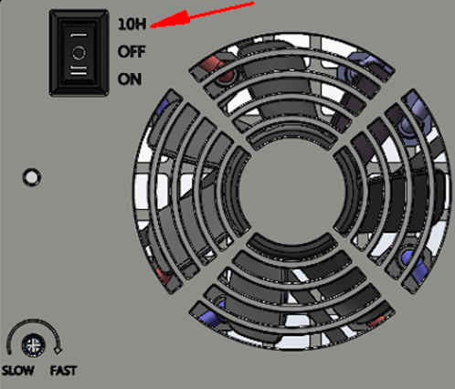

- When TIMER function is selected, the device will be ON for 10 hours.
- Blue LED will be ON, indicating the device has been activated.
- After 10 hours, device will go into standby mode, indicated by the blue LED which will be off and will flash every hour
- After another 14 hours (24 hours from starting), device will be ON again
- For example, if power switch is moved to “timer” at 08:00 hour, the device is ON (blue LED is ON.) After 10 hours (18:00hour), the device will go into standby mode (blue LED will be off and will flash every hour.) After another 14 hours (08:00 the day after), the device will be ON again (blue LED is ON.)

Bi-polar ionizer lifetime indicator
The blue LED also works as the ionizer lifetime indicator. When the device goes
- from Power OFF to Power ON or
- from Standby(timer) to Power ON
it will show total operating time as below:
- <11,000 hours, in normal start-up, blue LED is ON
- <11,999 hours, in normal start-up, blue LED will flash 1 time, then continuous ON
- <12,999 hours, in normal start-up, blue LED will flash 2 times, then continuous ON
- >19,000 hours, in normal start-up, blue LED will be 0.5 seconds ON, 1 second OFF
- To reset the counter to 0 hours: press and hold > 7 seconds until it flashes 5 times fast, then release
- To check total operating time in increments of 5000 hours even after the counter has been reset: press reset button quickly 4 times and blue LED will flash times quickly and then flash for every 5,000 hours until 50,000 hours.
- For example, total operating time 17,000 hours: press reset button quickly 4 times and LED will blink 2 times quick and then 3 times slow to indicate > 15,000 hours operating time. The counter will not affect the total operating time counter. Service department can always check the approximate real operating time.

5) CLEANING AND MAINTENANCE

- The device is maintenance free
- Clean the device whenever necessary, using a damp cloth and some washing liquid.
- Never immerse the device in water or any other liquid.
- Switch off and unplug the device before cleaning.
- Never use aggressive or abrasive cleaning materials.

6) SPECIFICATIONS

• Voltage input: AC 220V-240 V, 50/60 Hz, Class II
• Power: 5 W
• Case materials: PC and ABS
• Fan speed: 3500rpm (max)
• Ionizers: 4 pieces Bi-Polar ~3.5kV - +3.5kV total 180 million ions per cm³
• Applicable Area: up to 80m³
• Virus Removal Rate: 99.9%
• Power on/off/timer switch
• Reset button
• Blue indicator light: when on device in operation
• Operation temperature: +5°C - +50°C
• Installation: desk stand and wall mount
• Dimensions apparatus: 110 x 110 x 75 mm
• Weight apparatus: 0.5kg

7) STORAGE & TRANSPORTATION

- When storing the device, it should first be cleaned in accordance with this user manual. The device should be stored in its original packaging.
- Always store the device in a dry and well-ventilated room and beyond the reach of children.
- Protect the device against vibrations and shocks during transport.

All contents and specifications mentioned in this manual are subject to change without prior notice.
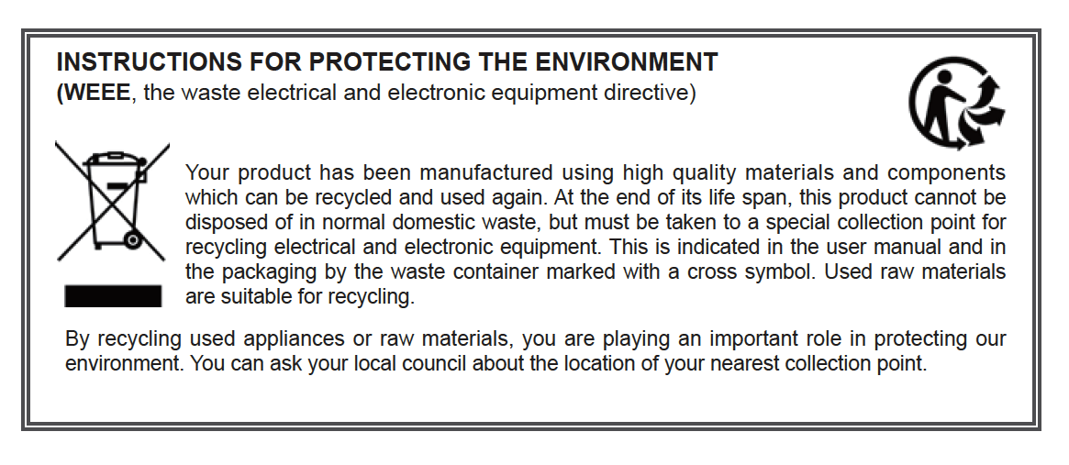

8) Disclaimer:
Supplier of the device does not assume any liability for the consequences arising out of the use, or misuse of the product, including any injury and/or damage to any person or property as a matter of product liability, negligence, or otherwise.
Product effectiveness has been tested independently to remove 99.9% of stated air borne viruses, but is by in no means 100% effective in the prevention of virus contamination and not a substitute for other preventative measures.

