Installation Guide
ablatum mini

IMPORTANT

- Carefully read this instruction guide before installing the ablatum mini (hereinafter “device”). Retain this instruction guide for future references.
- Thoroughly inspect the device and accessories for any freight damage; do not install the device if any damage is found.
- Always ask a professional or well-trained technician to install the device.
- The device is designed for indoor use.
WARNING

- RISK OF ELECTRIC SHOCK. Make sure the power supply is OFF before installing or maintaining the device or fixture.
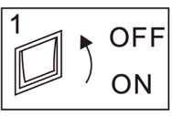

INSTALLATION

- CEILING MOUNTING
- RECESSED CEILING MOUNTING
- 3-PHASE 4-WIRE TRACK MOUNTING
- SINGLE-PHASE 2-WIRE TRACK MOUNTING

- CEILING MOUNTING

- Install the metal hanging bar on the ceiling using long screws provided:
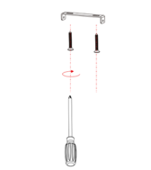

- Connect the Live and Neutral wires on the device to the main power line (220Vac)
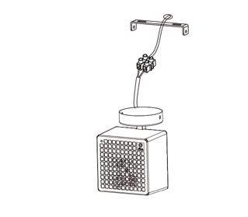

- Cover the hanging bar with device’s round top mount fixture and fix the two short screws in position.
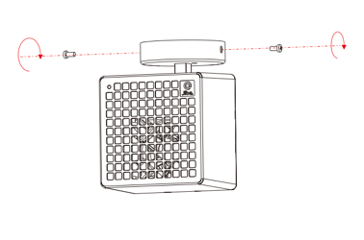

- Turn the axle and rotate the device to desired angle and position.
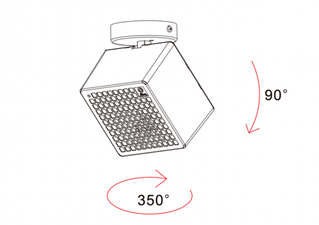

- The fan speed can be adjusted by turning the fan speed knob on the back. The higher the speed, the further the ions can be spread.
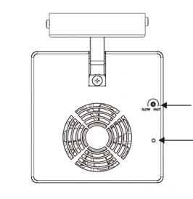

Fan speed trimming pot

Reset

- RECESSED CEILING MOUNTING

- Cut a hole in the ceiling with a diameter of 75mm or use an existing ceiling cavity
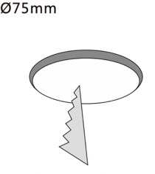

- Connect the Live and Neutral wires on the device to the main power line (220Vac)
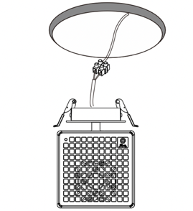

- Insert the top mounting fixture into the hole, with clips folded upward.
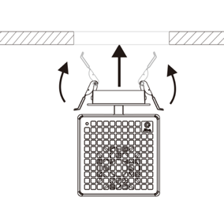

- Turn the axle and rotate the device to desired angle and position.
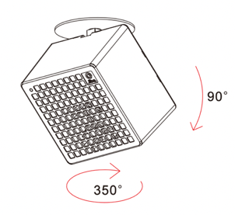

- The fan speed can be adjusted by turning the fan speed knob on the back. The higher the speed, the further the ions can spread.

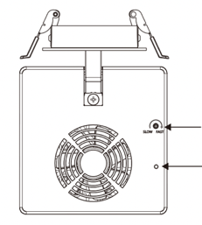

Fan speed trimming pot

Reset

- 3-PHASE 4-WIRE TRACK
WARNING – Do not touch the internal conductor inside the track rails, which may lead to an electric shock.

- Slide in the track adaptor to the track rails.
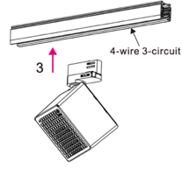

- Make sure shaft position illustrated is fixed and correctly positioned on the track adaptor so that it can affix to the track rails.
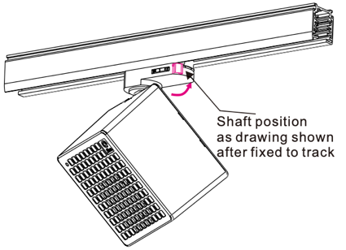

- Turn the knob to select phase 1/2/3.
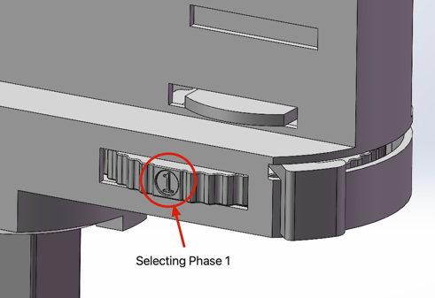
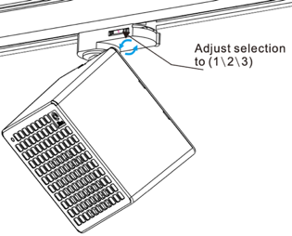

- Turn the axle and rotate the device to the desired angle and position.
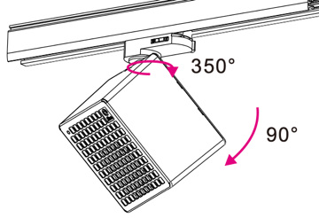

- The fan speed can be adjusted by turning the fan speed knob on the back. The higher the speed, the further the ions can spread.
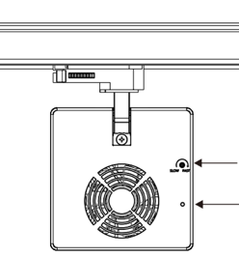

Fan speed trimming pot

Reset

- SINGLE PHASE 2-WIRE TRACK

WARNING – Do not touch the internal conductor inside the track rails, which may lead to an electric shock.

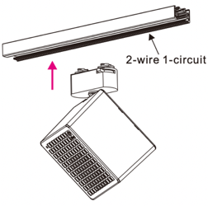
- Slide in the track adaptor to the track rails.

- Make sure shaft position illustrated is fixed and correctly positioned on the track adaptor so that it can affix to the track rails.
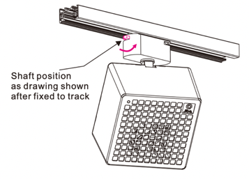

- Turn the axle and rotate the device to a proper angle and position.
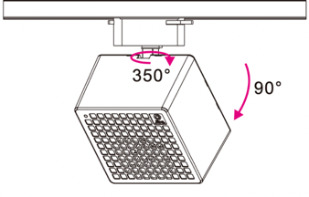

- The fan speed can be adjusted by turning the fan speed knob on the back. The higher the speed, the further the ions can spread.

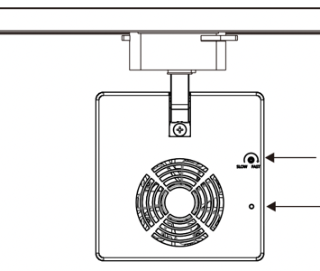

Fan speed trimming pot

Reset

--- END ---

