ablatum air AQM
User’s Manual

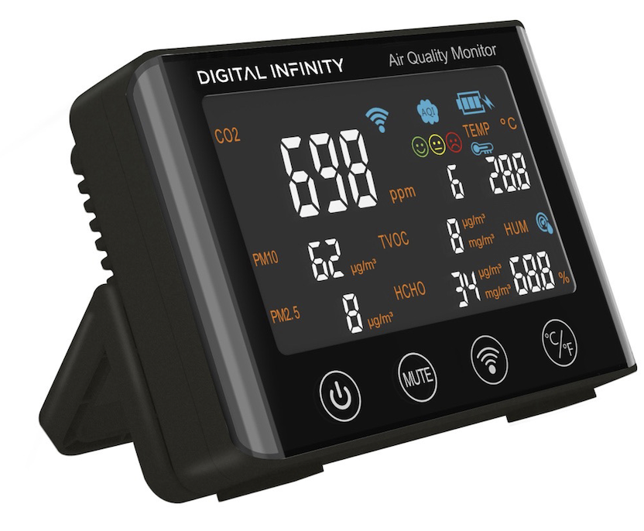

Special statement: The illustrations of the products, accessories and user interface in the manual are all schematic diagrams and are for reference only. If there is a difference between the actual product and the schematic diagram due to product updates and upgrades, please refer to the actual product received, and the manufacturer will not notify you separately.

Before starting
- This product should not be submerged in water, nor should it be placed in a high temperature environment exceeding 60℃.
- This product is a precision measuring instrument and should not be dismantled which can impact the products performance, unless done so by an authorised person.
- Do not expose the device to extremely high concentrations of organic gas as this may damage the sensors
- The product has a built-in lithium battery and should avoid being exposed to direct sun for a prolonged period

Product Drawing
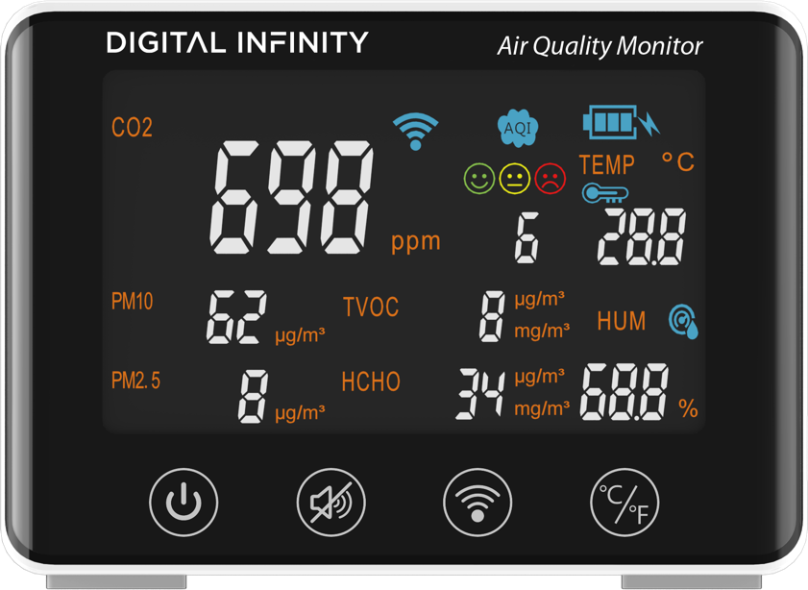
WIFI connect Icon

AQI Value
Power on/off
Alarm Mute
WIFI disconnect
°C/℉ toggle

Face indicator

Wall Mount
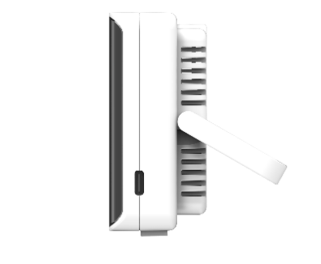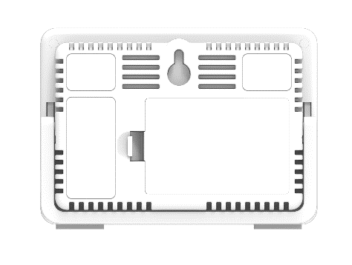
Fence for Sensor
Battery Cover
Table Bracket
Type C connector

Note:

- Press Power button 5 seconds to power the device on or off.
- When the device is alarming, user can press the Mute button to silence. After 15 seconds, the audible alert will resume if the measure still exceeds acceptable thresholds.
- To turn off the audible alarm function on the device, press and hold the Mute button for 5 seconds, until there is a short beep. Please repeat this process to turn the audible alert function back on. When the LED is green, this will indicate that the audible alarm function is on; when LED is off, this indicates that the audible alarm function is off.
- If the device is not found in the Tuya Smart app, press the WIFI button for 5 seconds to disconnect/reset the WIFI network setting in device
- Press C/F button, to switch temperature between ℃ and ℉.
- Fences are positioned around the device to allow the device sensors to measure the air quality. Please do not obstruct the device to ensure effective operation.
Alerts
The device comes with expression icons that are aligned to the international CO2 value standards. The expression and indicator lights will change as illustrated in the table below:

Good | Normal | Bad
400-999ppm | 1000-1399ppm | over 1400ppm
 | Alarm 5 times every 15s | Alarm 10 times every 15s

Main Specification
- Product Name: ablatum air AQM
- Model Name: DI-AAAQM-1000
- Detecting Item: CO2 / Temp / Hum / AQI / HCHO / PM2.5 / PM10/TVOC
- Material: ABS/Acrylic/Electronic Components/Air Sensors
- CO2: 400-5000ppm (±50ppm + 6%)
- PM10: 0-999μg/m³
- PM2.5: 0-999μg/m³
- TVOC: 0-9999μg/m³
- HCHO: 0-6250μg/m³
- AQI: 0-99
- Temperature: 0-55℃ (C/F switchable)
- Humidity: 0-99%
- WIFI icon: WIFI function active, display WIFI icon
- Battery icon: Shows battery usage and charging status.
- AQI icon: AQI value based on PM2.5 value, displaying value will be from 0-99.
- Li-Battery: 1200mAh (Working time: around 3.5 Hours)
- Type-C Power Supply: 5V/1A
- WIFI: IEEE802.11/b/g/n 2.4GHz
- Bluetooth: BLE5.0
- Size: 123*86*32mm
- Weight: 300g
- Working current: 5V/500mA
- Rated Power: 5W
- Standby Current：< 3mA
- WIFI supporting: Tuya WIFI+BT CB3S (Optional)
- Connecting Platform: Tuya APP / PC tool / Tuya Server

APP Usage:
- APP name: Tuya Smart
- App icon & QR code:

3. App Installation
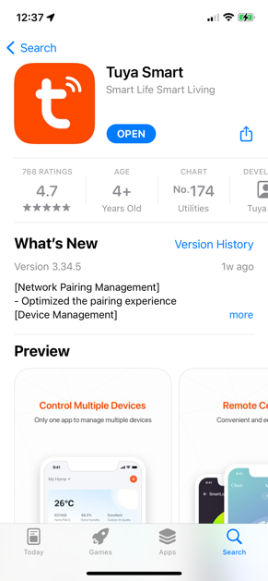
- Download and Install Tuya Smart from
Apple Store or Google Play:

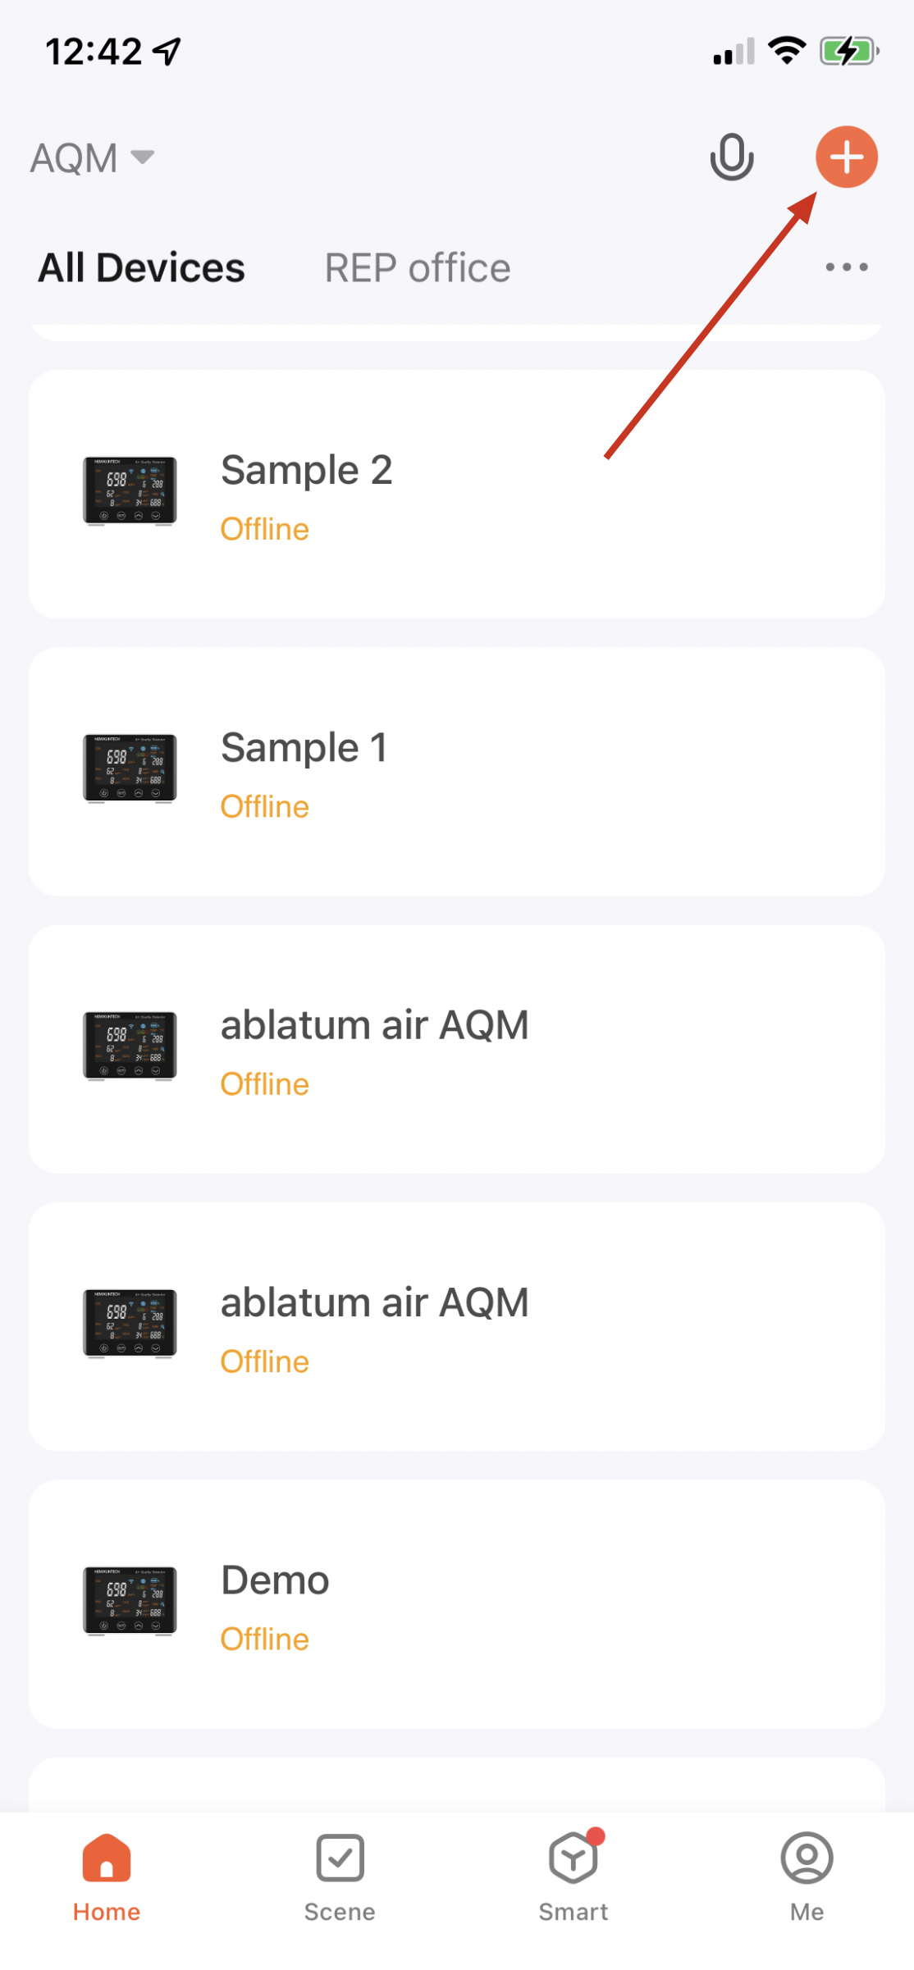
- Launch the Tuya app. and choose add device by selecting at the upper right corner and select “Add Device”

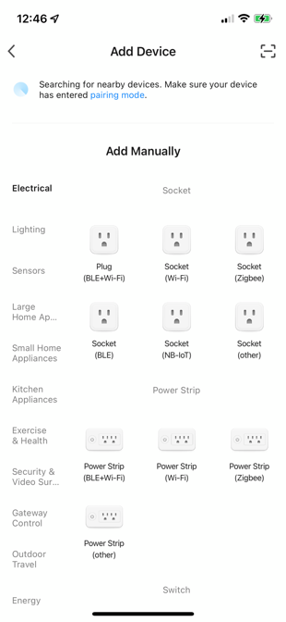
- Tuya app. will go into auto search mode. Make sure your mobile phone Bluetooth and WIFI functions are ON.

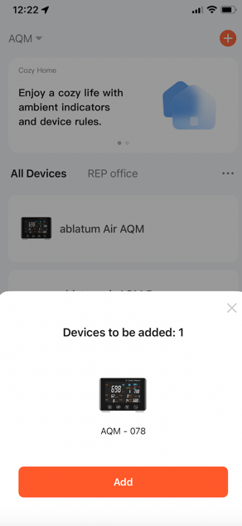
- If device (AQM) is found, the Tuya app. will prompt user to add the device. Simply click the Add bar when prompted.

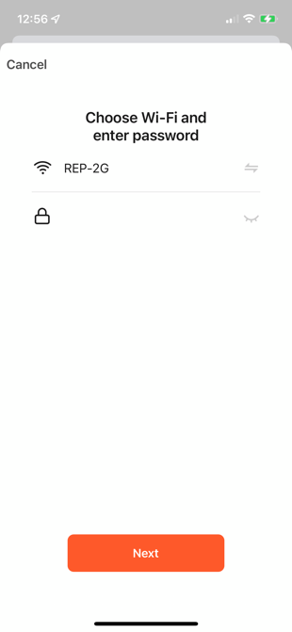
- Choose Wi-Fi network (Tuya app. supports 2.4GHz WIFI network, not 5GHz WIFI network) and enter password. Then press Next

- Devices is now successfully connected. 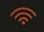 will be displayed on AQ

4. App. alert message setting
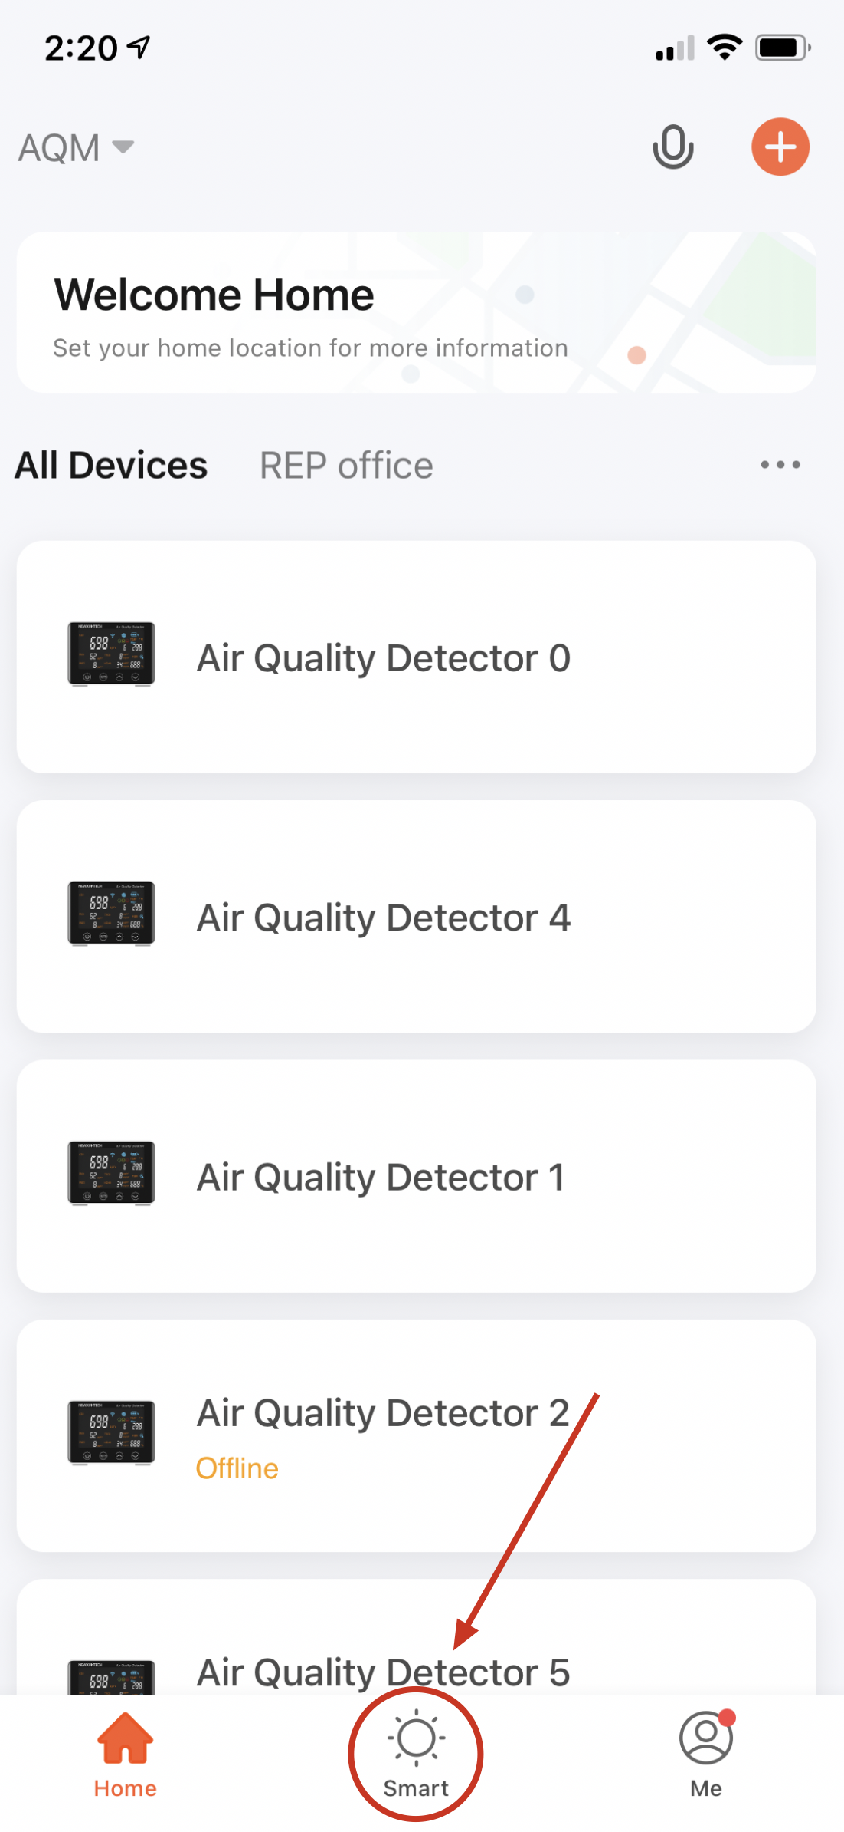
- On the Tuya Smart homepage, select Smart at the bottom

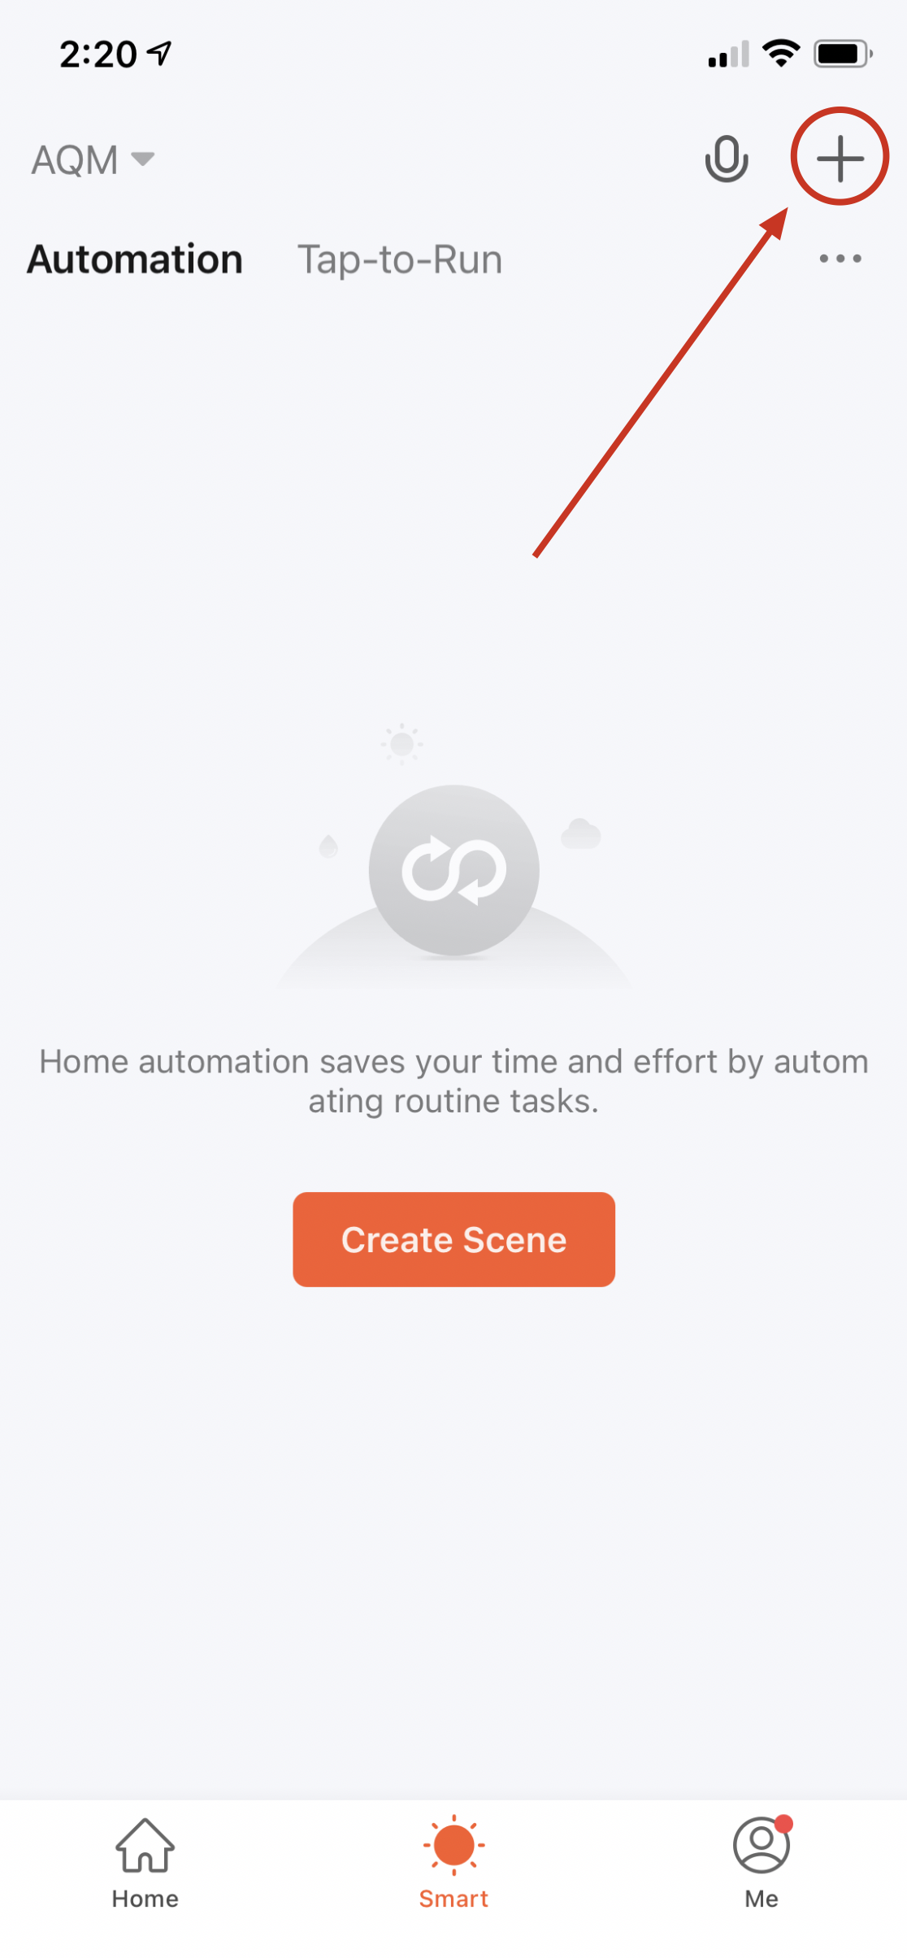
- On Smart page, click “+” at upper right corner to add task.

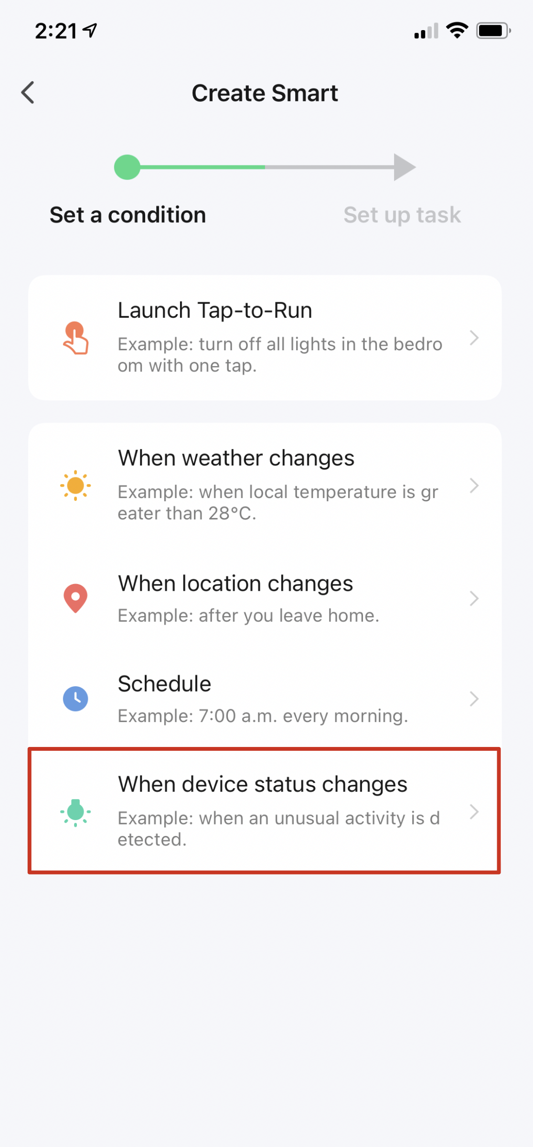
- Select “When device status changes” on “Create Smart” page

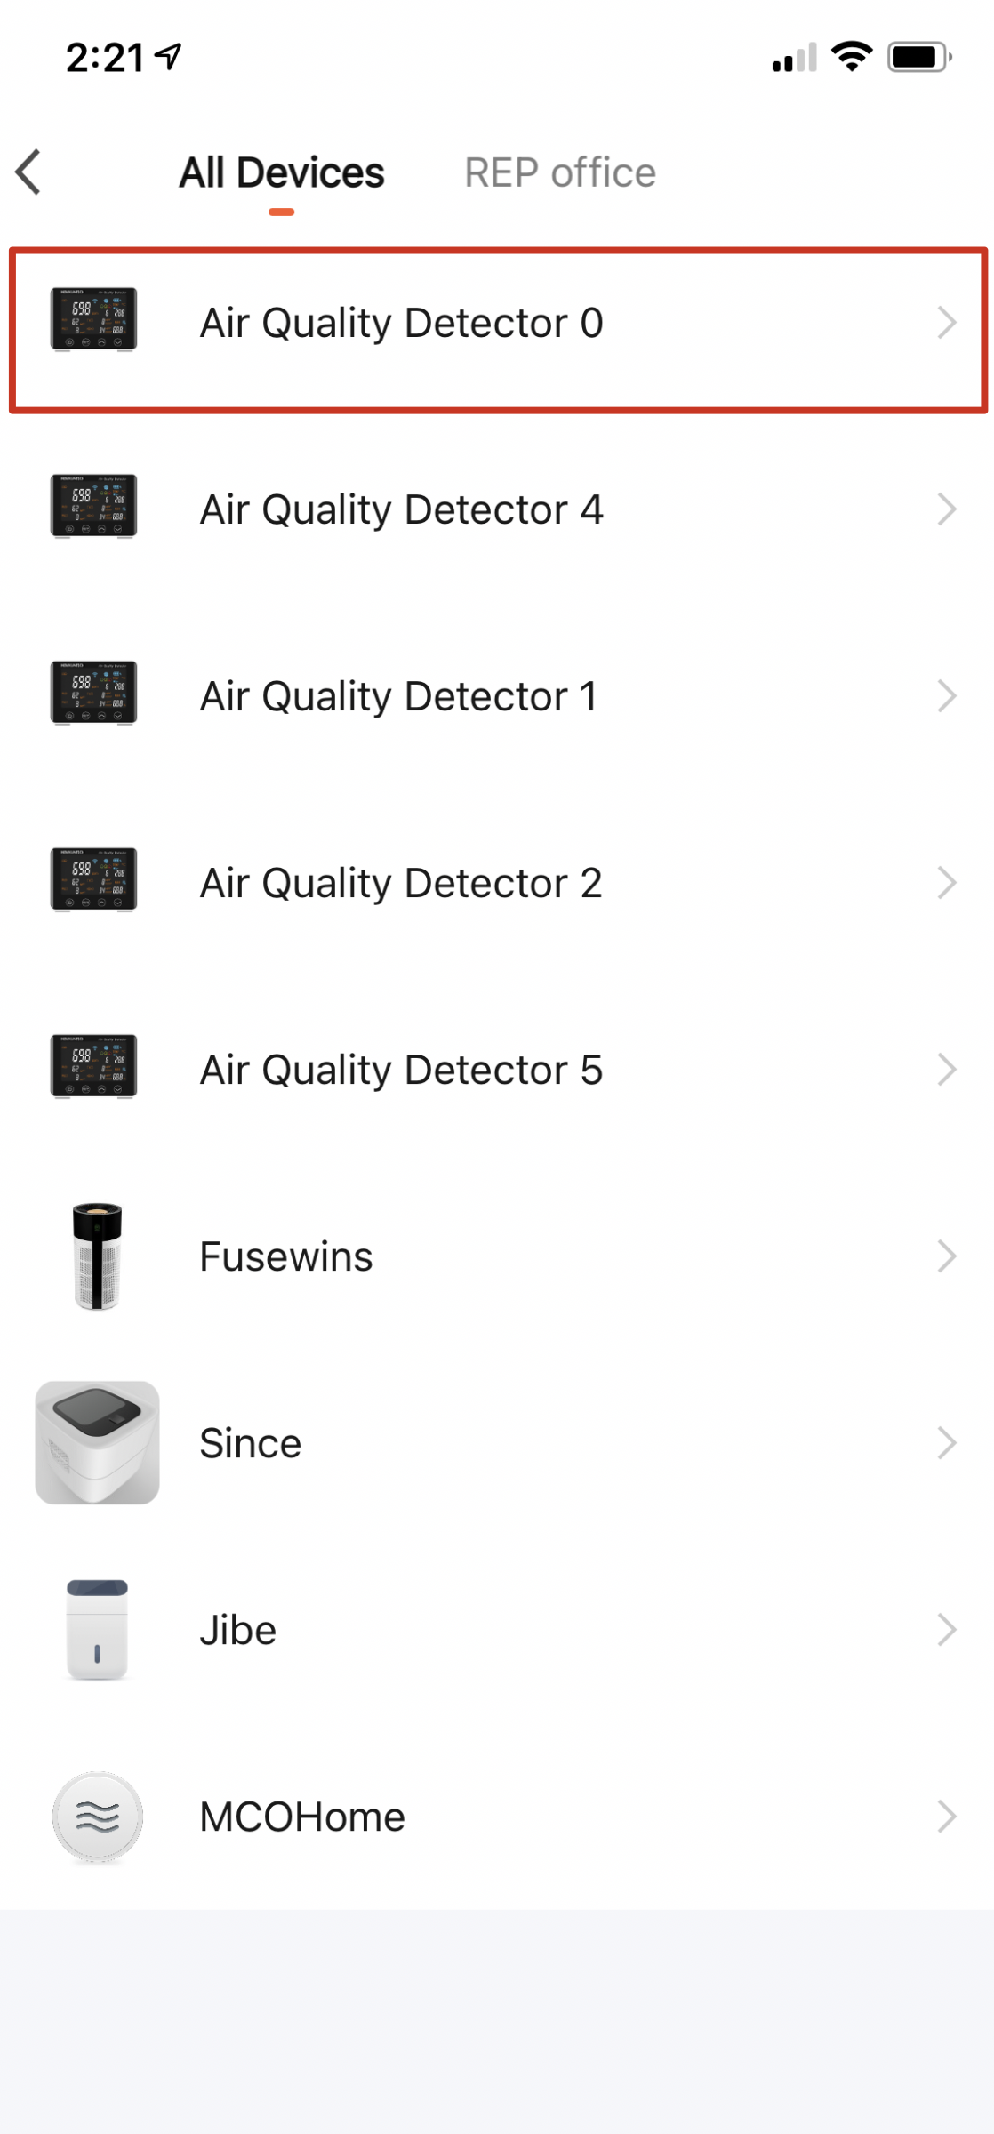
- Select the device you want to do the automation.

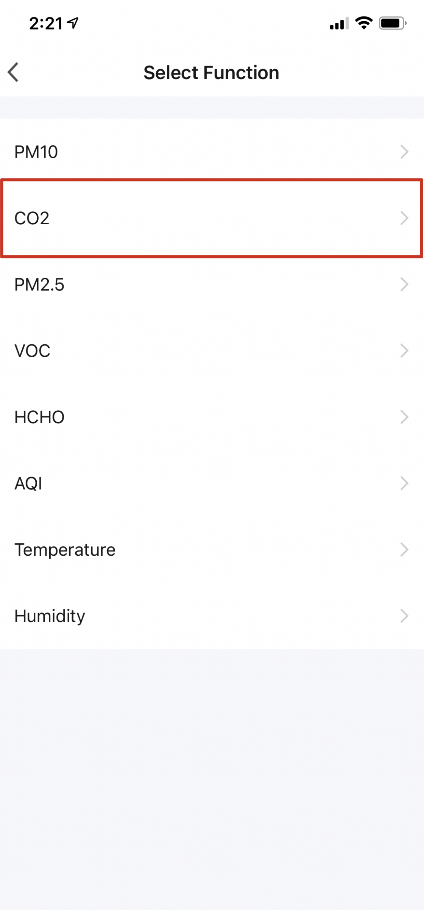
- Select the sensor for message alert, in this case, CO2.

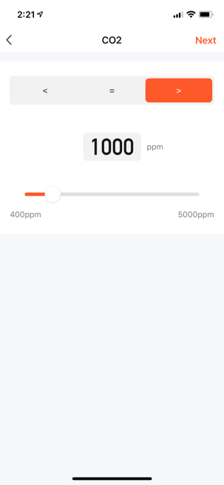
- Set your alarm conditions, e.g., CO2 concentration over 1000ppm

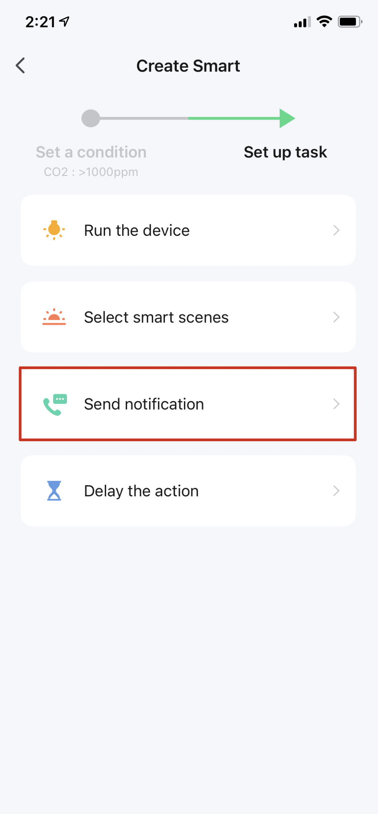
- Set up the task, in this case, choose “Send notification”

- Enable Message Centre

- Task condition and task name will be displayed.

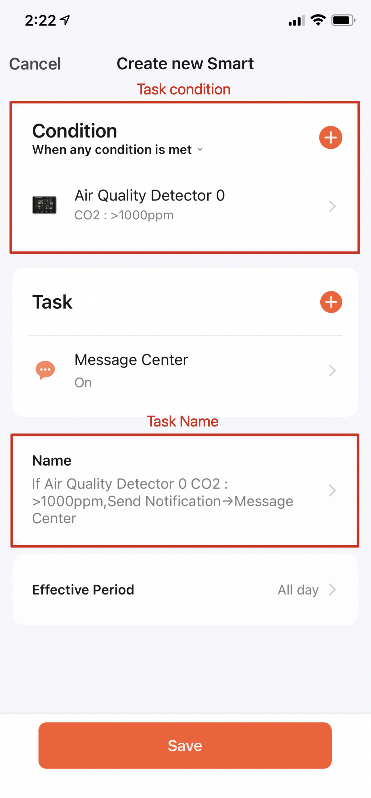
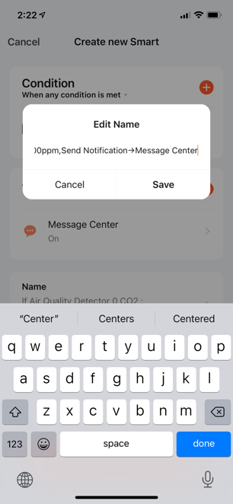
- Click on task name to rename task (Backspace to delete and then re-type
your new task name)

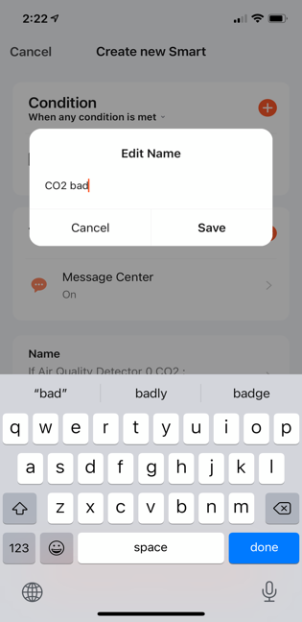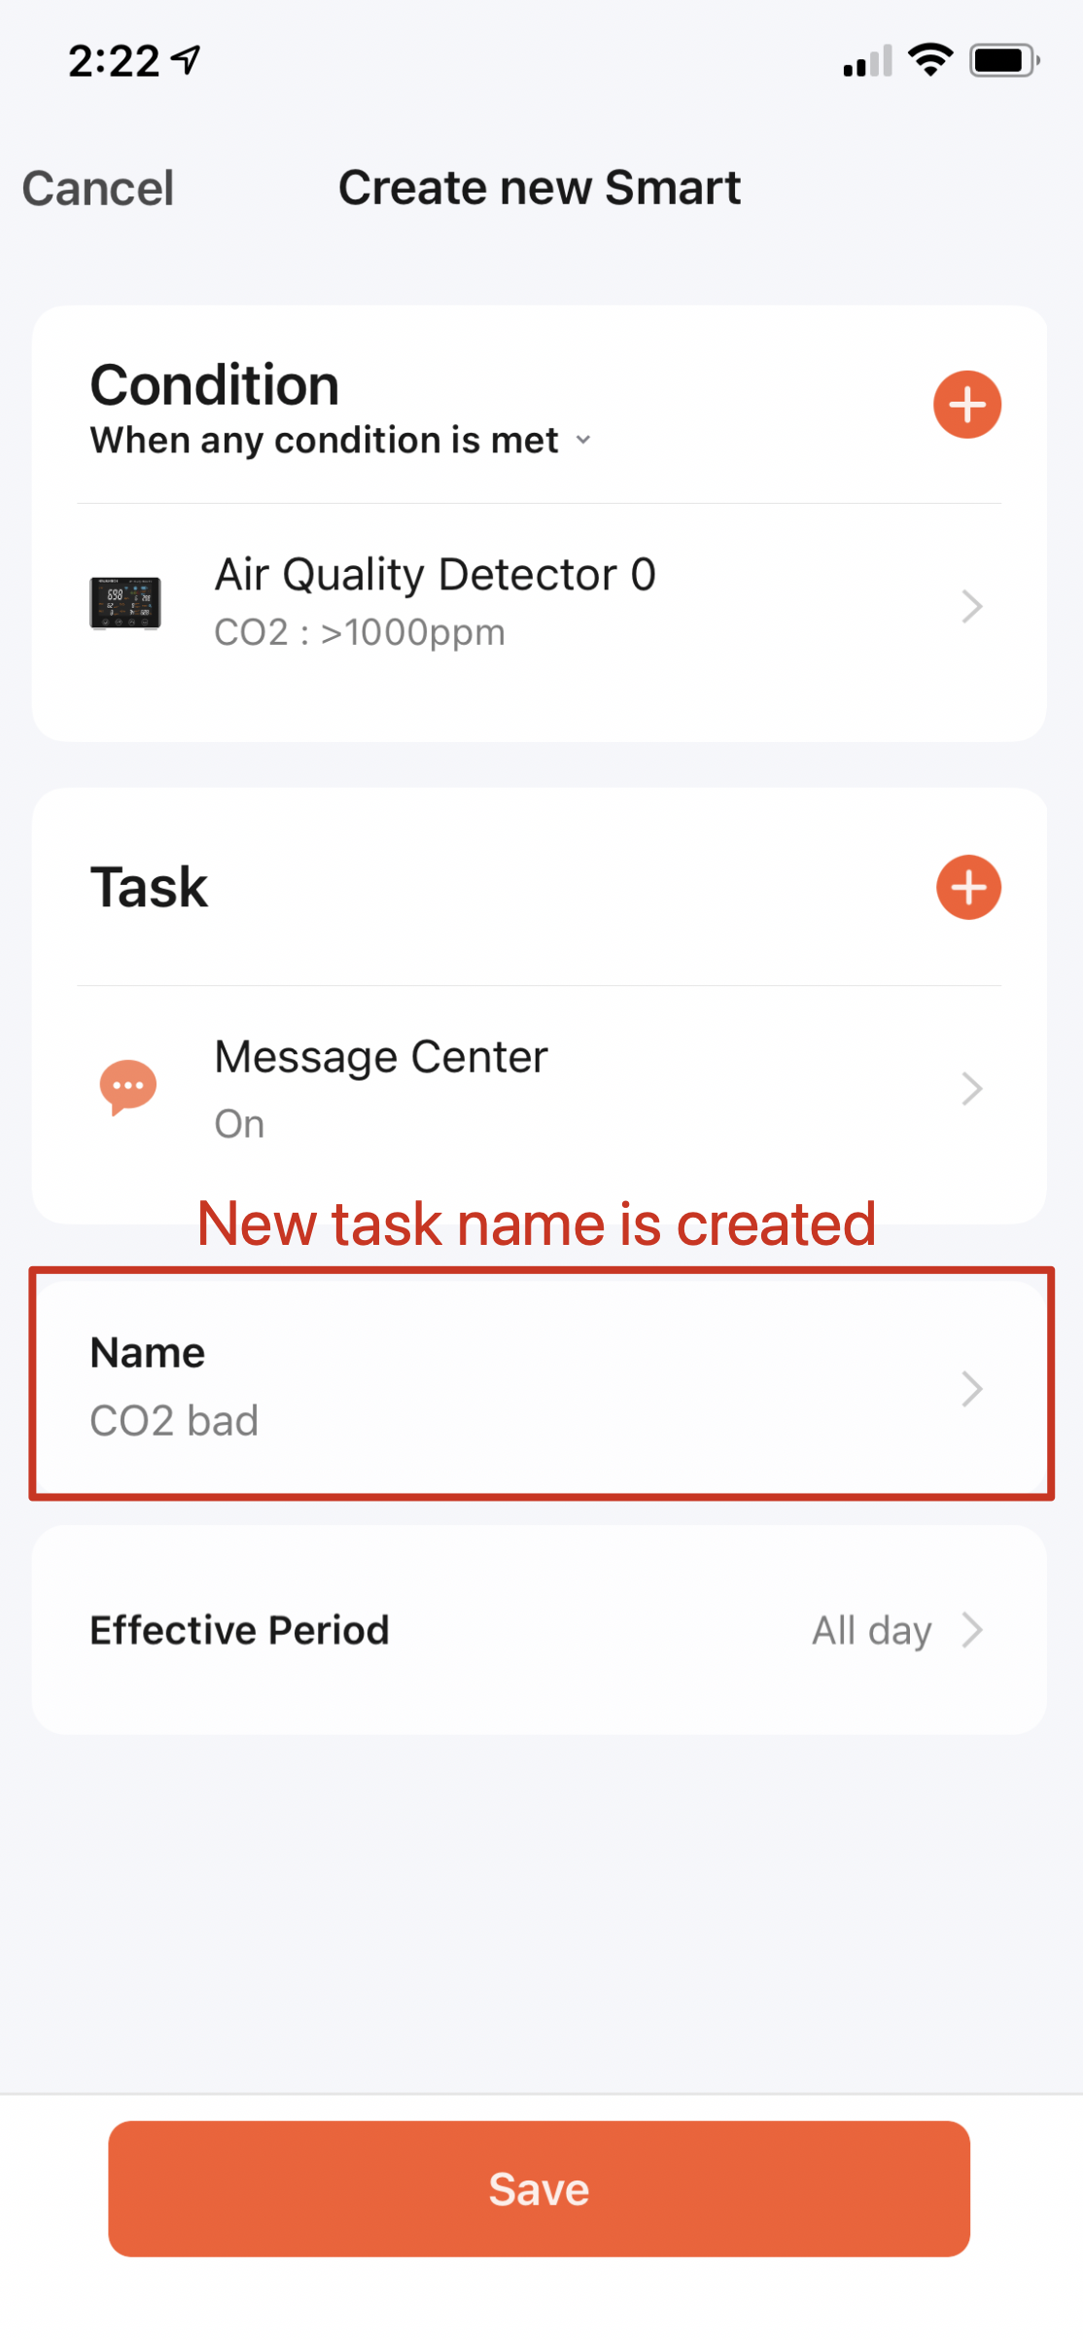
- For example, new task name is “CO2 bad”

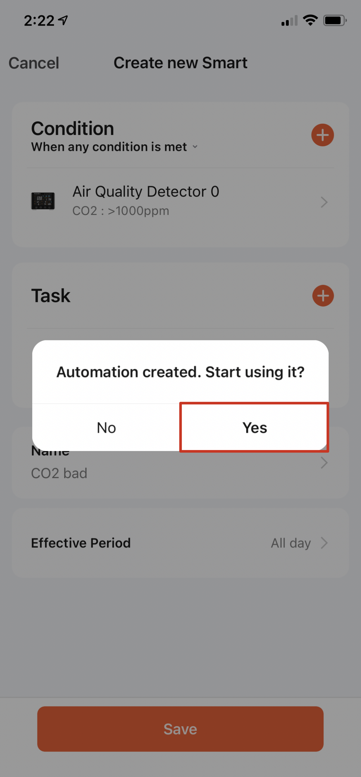
- After saving the task, choose “yes” to start using it

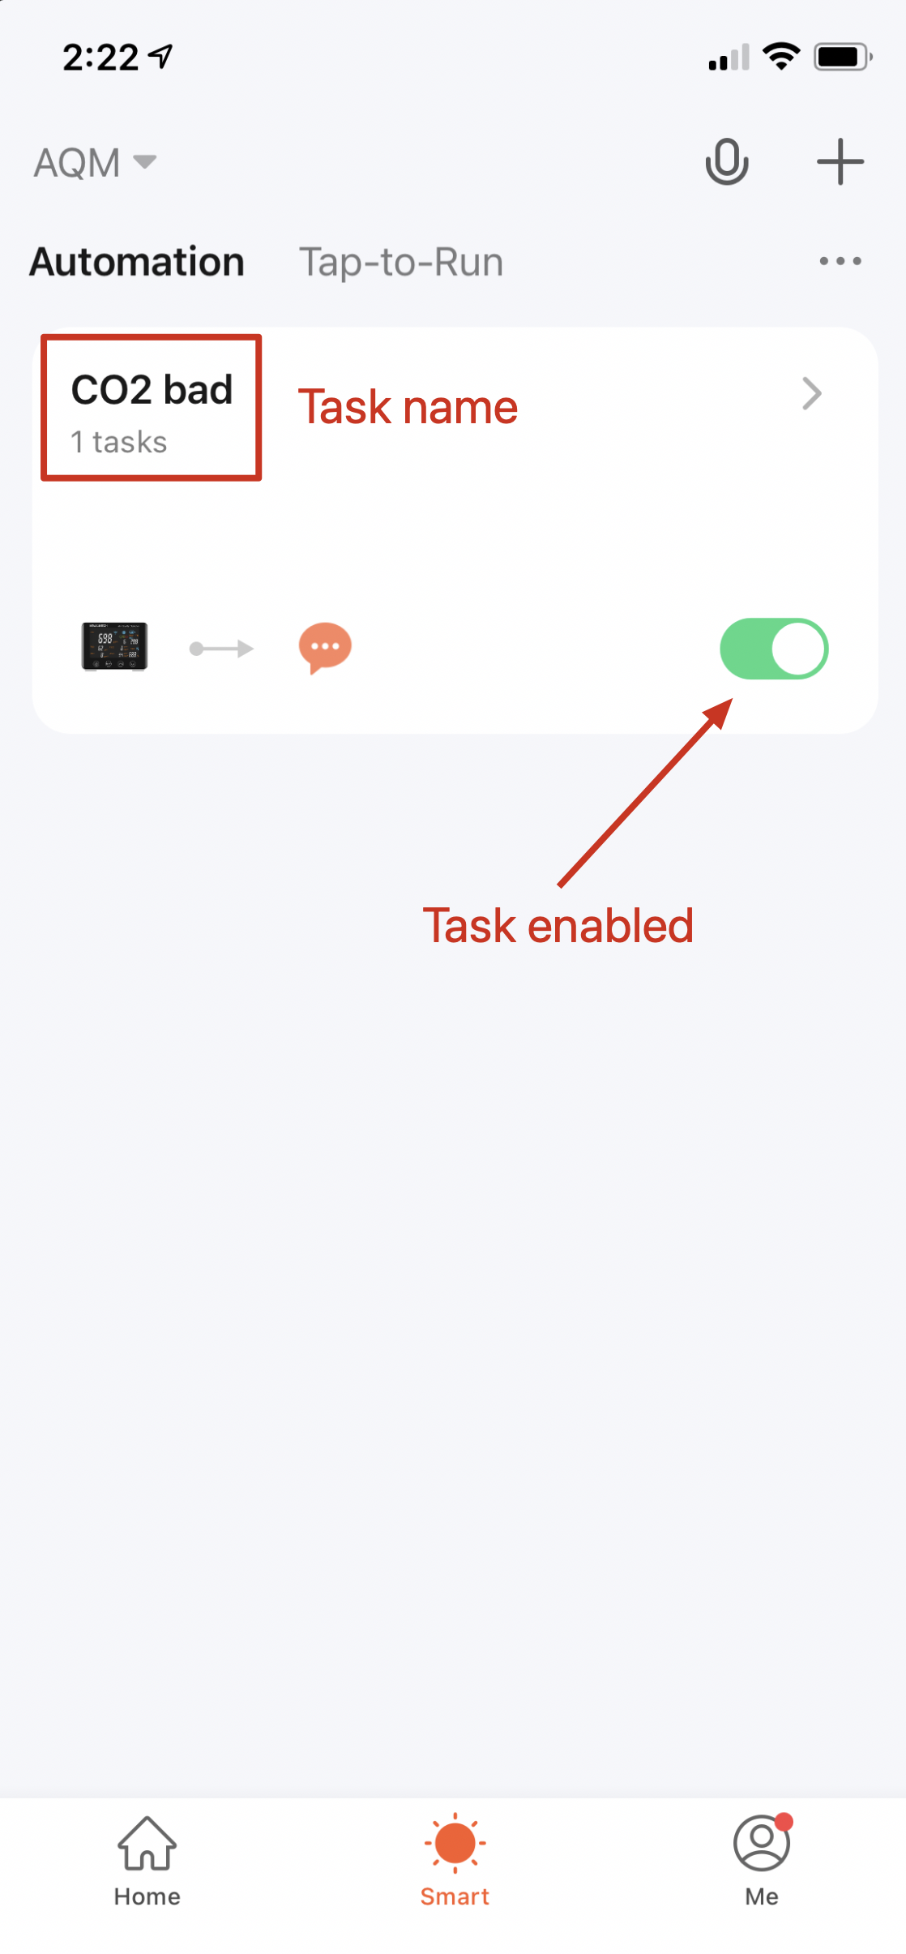
- After saving the settings, user can see the task on Smart page:

- To add more tasks, repeat step 2 to step 12.

The following table provides a guide to the international air quality standards and defines Good, Normal and Bad under each of the air quality measures and should be used as a guide when setting alerts.

Sensors/Measurements  (Measurement Range) | Good  Green colour | Normal  Orange colour | Bad  Red colour
AQI: 0-99 | 0-20 | 21-40 | 41 or above
Temperature: 0-55℃ | 18-25 | 10-17.9, 25.1-32 | 0-9.9, 32.1-55
Humidity: 0-99% | 40-70 | 20-39.9, 70.1-85 | 0-19.9, 85.1-99.9
CO2: 400-5000ppm | 400-999 | 1,000-1,400 | 1,401 or above
PM10: 0-999µg/m3 | 0-150 | 151-300 | 301 or above
PM2.5: 0-999µg/m3 | 0-50 | 51-250 | 251 or above
TVOC: 0-9999µg/m3 | 0-600 | 601-3,000 | 3,001 or above
HCHO: 0-9999µg/m3 | 0-100 | 101-500 | 501 or above

In the Tuya Smart app. homepage, select the AQM device and user can see clearly AQI, Temperature, Humidity, CO₂, PM10, PM2.5, TVOC, HCHO readings in one screen.

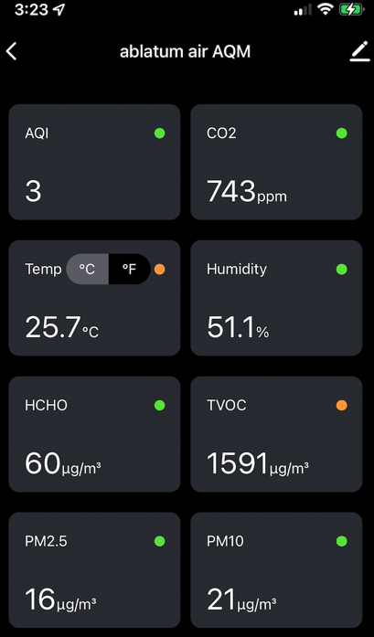
Green colour dots indicate the corresponding gas/pollutant status is in good condition.
Orange colour means it is in normal condition, while red colour means bad condition.

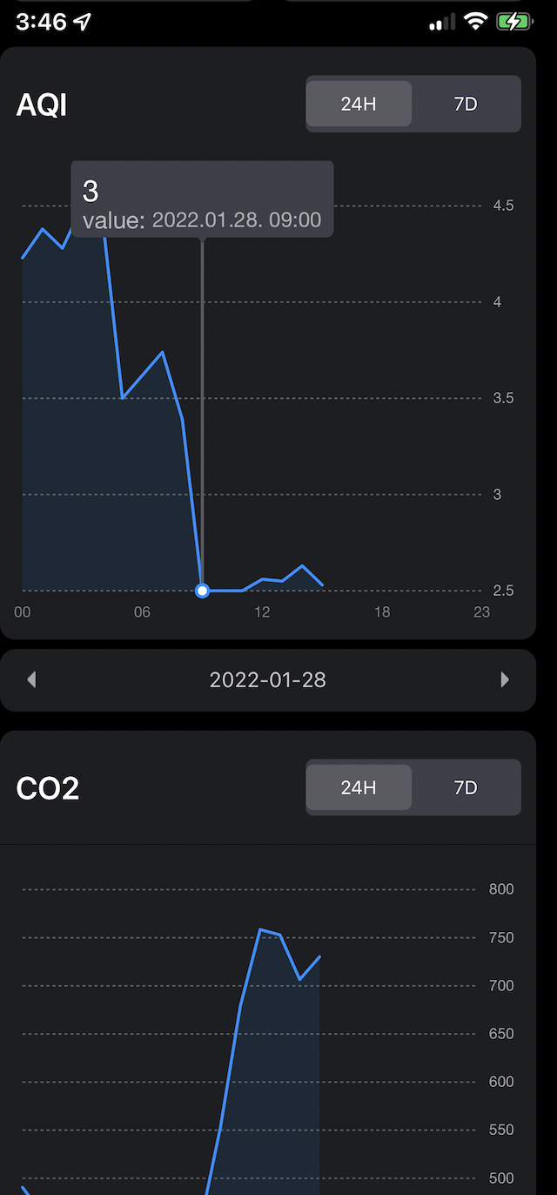
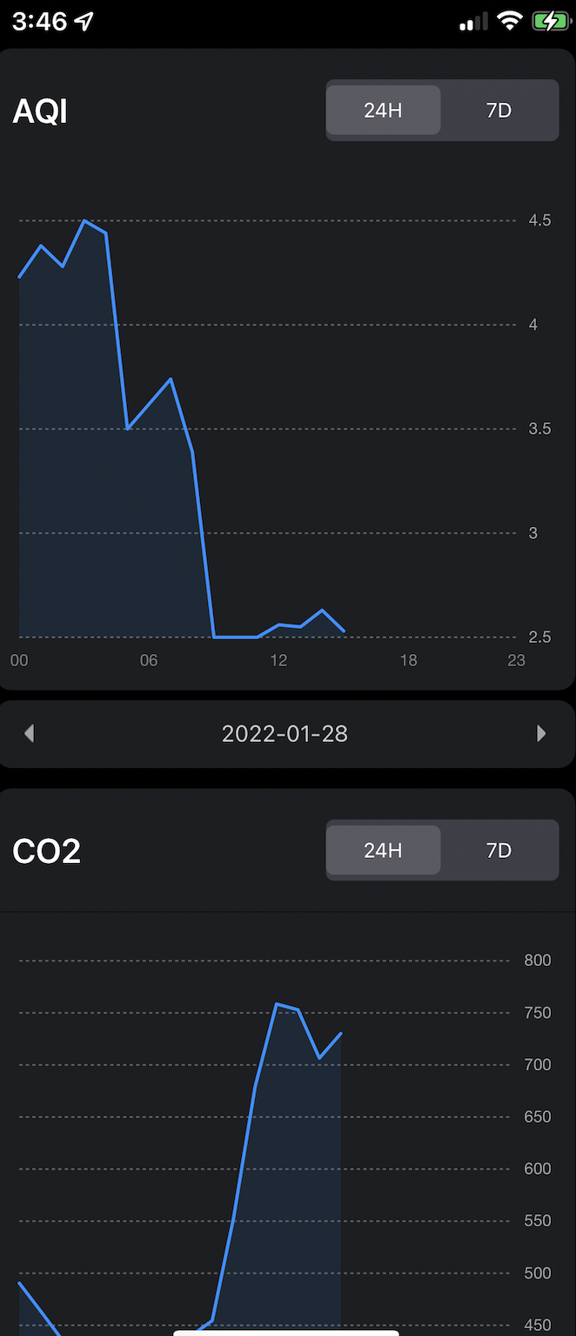
Scrolling down from dashboard the historical data chart will display. User can click on the curve to see the exact reading at that time interval. Historical data is stored for every hour. User can choose to check 24-hour data, or 7-day data.
PC Tool using(for Windows PC)
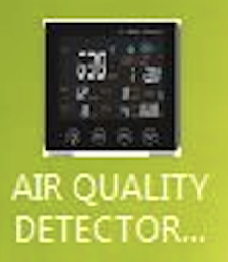

Before using, please check if your computer is running in Windows platform and support CH340 serial port. User can check the stored data measured hourly in device via PC tool.

Download link for AIR QUALITY DETECTOR PCTOOL V1.0.EXE and CH341SER.EXE

www.thedigitalinfinity.com

PC Tool installation and operation
- Copy the file AIR QUALITY DETECTOR PC TOOL V1.0.EXE to your PC.
- Connect AQM to PC USB port through USB-C charging cable provided.
- Run AIR QUALITY DETECTOR PC TOOL V1.0.EXE
- Select COM port that your device is connected to (usually COM3)
*Some computers may need to install the CH340 driver. If COM port is not shown in PC TOOL program, close AIR QUALITY DETECTOR PC TOOL V1.0 and install the driver(CH341SER.EXE). After the installation, run AIR QUALTIY DETECTOR PC TOOL V1.0 again.
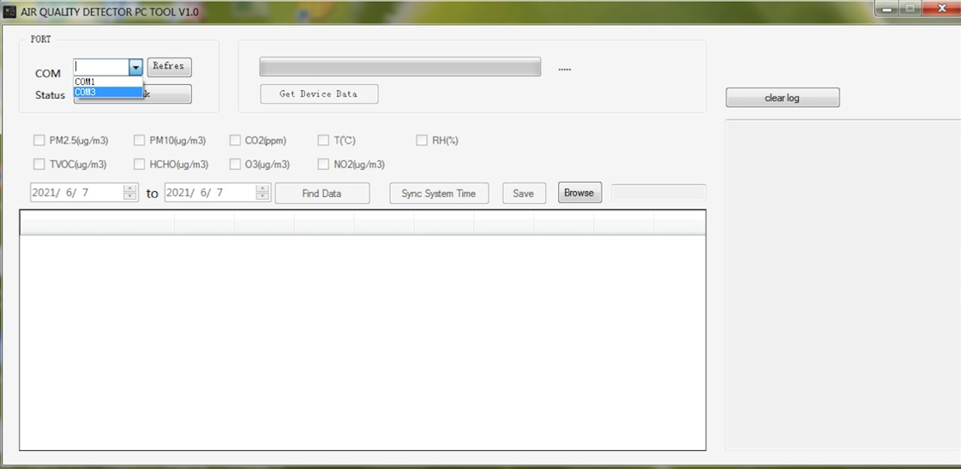
- Press “link” and “Get Device Data”, stored data will be retrieved.
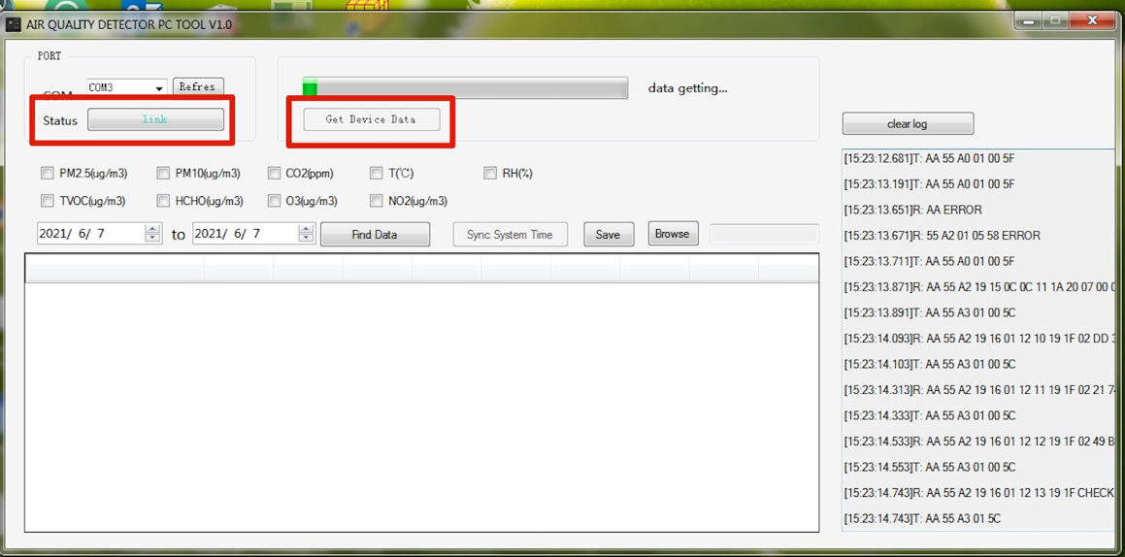

- After data is completed, downloaded (get data finish), click the air pollutants, the starting date and end date that you want to review. Then press “Find Data” and all the measurements per hour during this period will be shown.
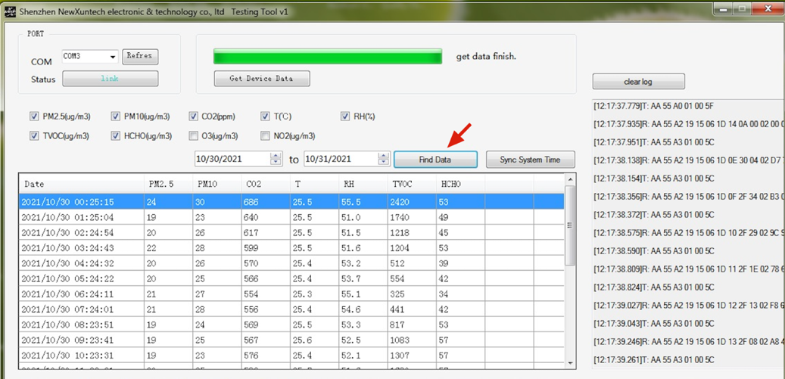

User can also save the data to excel file by clicking “Save” icon. To change file storage directory, click “Browse” icon and select desired folder or path.
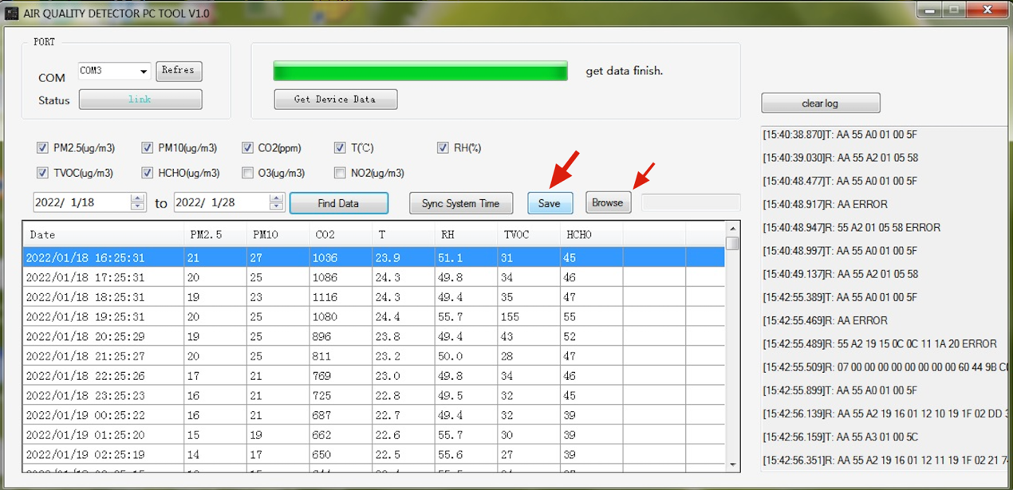

Note 1: The PC tool requires device working for at least 24 hours.
Note 2: If user wants to view the data today, then date must be set from YYYY/MM/DD to tomorrow’s date. For example, if today is 2022/1/10, and user wants to view data from 2022/1/1 to today, then the date must be set from 2022/1/1 to 2022/1/11.
Note 3: If data cannot be successfully downloaded, switch off and switch on the AQM while it is connected to PC to refresh the FLASH memory and repeat the PC Tool operation process again.
Note 4: Device can store up to 1 month data.

